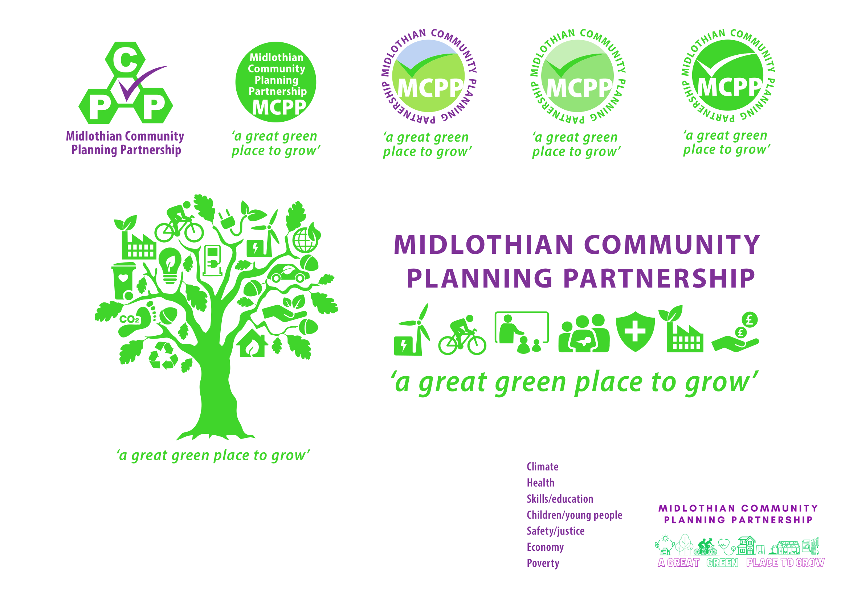
Community Planning Partnership Board Meeting
Thursday 30th January 2025 at 10.00am via Microsoft Teams

Present – Andrea McCann, Annette Lang, Dona Milne, Elliot Whitson, Fiona Kennedy, Gill Main, Grace Vickers, James Robertson, Jim Sherval, Kevin Anderson, Lesley Kelly, Lynsey Davidson, Myra Forsyth, Nick Clater, Nora Fedra-McKay, Rebekah Sullivan, Roddy Henry, Ann Stewart-Kmicha

Apologies – Audrey Cumberford, Bryan Pottinger, Claire Ross, David McCallum, Jamie Bell, Jane Burnett, Keith Fisken, Michael Jeffrey, Michelle Strong, Morag Barrow, Rebecca Hooton, Steven Young, Murray McEwan,

Agenda Item | Minutes | Action
Approval of minutes | The board approved previous meeting minutes
Matters arising | Midlothian Council - Net zero target 2045  Annette Lang (AL) advised she has discussed with the climate change officer and the CP Board have stated they are willing to realign to 2045 target and wish to reinforce their commitment to climate change even though the target date has been changed.  Lesley Kelly (LK) stated for purposes of minute she would have concerns however appreciate the resources available to work on this.  Ann Stewart–Kmicha (ASK) noted that Federation of community councils would be in a similar mindset.
Action Log | The action log was reviewed and updated.  Kelly Parry (KP) raised her concerns about the increase in national insurance contributions. KP has written to Kirsty McNeil to joint chair round table discussion with community planning partners. Awaiting a response.
CPWG update | COSLA attended the CPWG and provided information about no recourse to public funds.  COSLA have migration and population team for local authorities to approach in terms of further support.  COSLA suggested in kind support was appropriate for those with NRPF. | Presentation to be circulated with minutes (in working group minutes)  Any questions/comments to be fed back to Annette or Rebekah
CPP conference report | Rebekah Sullivan (RS) gave a presentation which highlighted the key points from the conference. The Board agreed that there would be no conference in 2025 however smaller learning events could be organised. Consideration of future themes for the Citizens Panel was raised. | Suggestions of where the graphic summary of the conference should be displayed to be sent to RS.

Scotland Census Interactive Map | https://www.scotlandscensus.gov.uk/atlas/choropleth?lad=S12000019  Suggestions for use could be for funding application or targeting of flyers/leaflets.  Grace Vickers (GV) suggested we share with cost-of-living task force. Further analysis is required and could focus on top 3 things that would make a difference in each locality.  Ann Stewart-Kmicha raised the need for caution as statistics do not show a complete story. There may be other reasons e.g. dynamic for house building for disabilities so different way of viewing statistics.  It was suggested we arrange a workshop on how to use statistics in a meaningful way.  LK – it is requested that the Third Sector be included in any census training sessions.  ASK requested statistics on the pupil role projection for federation of community councils | Task for board to find out 1 thing you didn’t know about Midlothian.  Fiona Robertson to send statistics to Ann.
Child Poverty Report | Fiona Robertson presented the report on year 6 child poverty action report. This report sets out actions taken in 23/24 and outlines future plans to support families and reduce child poverty in Midlothian. The report is a collaboration involving Midlothian Council, NHS Lothian and other stakeholders. Fiona highlighted that good progress has been made across a range of the priority actions.  Thanks were given to Dona Milne for work in her as role as champion for Reducing Poverty.
CPP Self Evaluation Summary Results | The Board were reminded that the National Community Planning Self-Assessment will be held on 24th March 2025. The self-assessment is based on 17 responses. From an initial analysis of the results, feedback and comments are positive with some areas for improvement.
AOB | Community Justice Self Evaluation  Fiona Kennedy (FK) updated from the Community Justice Partnership. In August 2024 the care inspectorate wrote to all Local Authorities to advise that they had renewed intention to look at scrutiny activity and how they are functioning.  The newly appointed co-ordinator will be taking the Community Justice Board and Working Group through the core assurance template and will submit it back to Community Justice Scotland.  New Community Planning Teams Channel  AL provided an update that the teams channel has been created externally on teams. This means that partners can work on documents at same time. Although all members of the channel will be able to see the draft versions of documents being produced.  LCTS meeting  KP highlighted that Lothian Community Transport Service have funding to provide a transport service aimed at women. The Board would welcome a presentation on this project at a later date.  LK highlighted that the community health and wellbeing fund will operate again in Midlothian.  Lynsey Davidson (LD) - national and regional updates from skills development Scotland to be circulated.  Elliot Whitson (EW) –  Reminded partners that the Scottish Fire Rescue service will be relaunching home fire safety visit from 12th February, data sharing framework has been shared previously. | Board Members to provide feedback to AL if able to see and access channel.
Date of next meeting | 27th March 2025 10am via MS Teams

