name of project:
Amount Applied for (£):

SECTION 1
Please tell us about your group or organisation.
(What do you do? Where do you meet? Who comes to your group? Give as much information as possible to help us know more about your group or organisation).

(Please continue on a separate page if required)

Do you have a constitution (or a set of rules)? Please circle or highlight.
Yes | No | Would like support to create one
Is this application sponsored by a constituted organisation?
Yes | No

Please provide the following information if you have it
League / Governance / Body Registration or Affiliation Number

Charity Number
Company Limited by Guarantee Number
SECTION 2
Please tell us what you would like a grant for and why?

How will this promote healthy eating, support community growing schemes, alleviate food poverty, or address any other healthy food related activity in Mayfield and Easthouses?

SECTION 3
Please list everything you will purchase/pay for with this grant. Please make costs as accurate as possible and if any item costs more that £100 be aware that you will need to provide at least one quote.
Item or activity | Cost | Total cost requested
TOTALS

SECTION 4
Group name:
Applicant’s name:
Address:
Postcode:
Contact
Contact email:
I confirm that I have the authority to submit this application on behalf of my project/organisation.
I agree to this application being shared with the funding panel and with members of the public at the decision-making event.
Signature:
Position:
Date:

The closing date for applications is: Monday, 8 May 2017

Please ensure you have enclosed a copy of your constitution or set of rules.

The steering group reserve the right to ask for further information regarding your application, which you are obligated to provide.

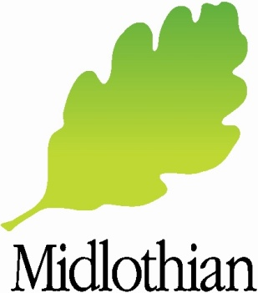
Return form (s) by email to: pbgrants@midlothian.gov.uk
or by post to:
Barbara Scott
Midlothian Council
Fairfield Houses
Lothian Road
DALKEITH, EH22 1DN

