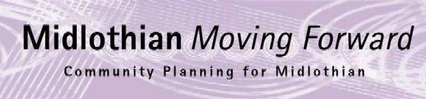
Community Planning Partnership Board Meeting
Thursday 31st March 2022 at 10.00am via Microsoft Teams
Present
Andrew Anderson (on behalf of Hilary Sangster) – Scottish Fire and Rescue Service
Ann Stewart Kmicha – Federation of Community Councils
Annette Lang – Group Service Manager (Community Planning and CLLE)
Rebekah Sullivan – Community Planning Development Officer (minutes)
Annie Watt – Economic Development - only attended part
Craig Sheerin – DWP Penicuik
Carolyn Hirst – Chair of Integration Joint Board
Diane Stockton – Consultant for Public Health
Dona Milne – Director of Public Health
Grace Vickers - Chief Executive Midlothian Council
Jim Sherval – Consultant public health NHS Lothian
Jim Muirhead – Depute Leader (Elected Member) Midlothian Council
Kevin Anderson – Director of Place
Lesley Kelly – Chief Officer MVA
Lynsey Davidson – Skills Development Scotland
George Archibald – Chambers of Commerce
Morag Barrow – Director Health and Social Care
Nick Croft – Edinburgh College
Peter Smaill - Councillor
Arron Clinkscales – Police Scotland
Roddy Henry – Newbattle abbey college
Mark McMullen – Scotent

Apologies
Audrey Cumberford - Edinburgh College
Dave McCallum - Skills Development Scotland
Fiona Robertson - Executive Director MLC
Garry Clark - Federation of Small Businesses
Gill Main - Health and Social Care
Hilary Sangster – Area Commander Fire and Rescue Service
Janet Lay Douglas - Elected Member MLC
Keith Fisken - Sestran
Kirsty MacDiarmid - Public Protection Team Manager
Penelope Curtis – Scottish Government
Dave McCallum - Skills Development Scotland
Nick Clater – Chief Officer Health and Social Care Midlothian Council

Note of Meeting

Minutes | Action
Welcome

The Community Planning Board would like to thank Jim Muirhead for his time as chair. We have valued your time and we wish you all the best for the future. Grace Vickers, Chief Executive Midlothian Council, gave a formal note of thanks acknowledging Jim’s collaborative leadership of the CPP and his dedication to communities.

Approval of Minutes
The minutes were approved with the correction that it is the launch of the adult learning strategy that is taking place at Newbattle Abbey College on 10th of May

There were no matters arising.
Action Log

The action log has been updated to reflect points raised.
CPWG Update and Recommendations
Ukraine

Grace Vickers, Chief Executive, thanked everyone who has been involved with organising support to refugees. It is key that we work closely with health groups to organise all aspects of support refugees may need.

Kevin Anderson – The sponsorship routes available to Ukraine refugees are different to resettlement schemes that we have done in the past. Data on the uptake of the sponsorship route is coming through however there is a concern around the safe guarding element as we won’t have data on the refugees. The council papers due to be published on this make reference to support available to those in need. Further details on how the council will do home inspections and ensure safety to those accommodating refugees will be circulated once received.

Joan Tranent – There may be a number of children coming with non-relatives. The duty then falls on local authorities to ensure those children are safe. Further guidance is being provided by the Scottish Government.

SDS have staff members who speaks Russian and can help with translation if required.

Community Planning Working Group

The Single Midlothian Plan 2021/22 is extended to June. It was agreed from 2023/24 to create a four year plan which will align with other 5 year plans. Updates on the different funding opportunities can be found in more detail on the community planning working group minutes, which have been circulated.

Draft Single Plan 22/23  The Single Midlothian Plan 2022/23 had been updated to make it clear, concise and straightforward for people to use.  Could board members please read the draft and if there are any changes send to R.Sullivan or A.Lang by end of April 2022. | ALL
The Promise and partner contributions  Progress is being made towards the promise and the approach is consistent with the Lothian’s and the Boarders councils. Funds of £100k has been achieved by the promise and a number of services have been set up, such as family group decision, life long links, youth justice work, community reach and an inclusion bus.  Once final report is approved Joan Tranent will update the Board at next meeting on what the requests for support will be. | JT
City Region Deal Update

Kevin Anderson presented the 9 big moves from the city deal, see below:
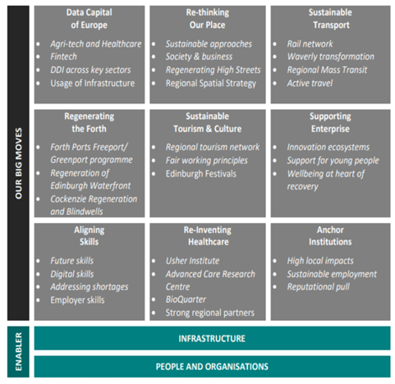
Lesley Kelly expressed the view that we need to look at governance to ensure the CRD reflects volunteering, community based activities and the aspect of shared prosperity.

Poverty and Community Wealth Building  Annette Lang had meeting with Paul McLennan to look at how East and Mid Lothian can work together on community wealth building.  The Strategic Poverty Prevention Group is being created and will run for a year. For those who want to sit on group please get in touch with A.Lang. | ALL
Community Planning Development Officer Update  Faith Partnership - The faith community partnership group has been re-established following a short break due to covid. The group will nominate a chair who will represent the group at CPWG meetings. Funeral poverty is still an issue for this group.  Citizen Panel Survey Commissioning -Tender requests to companies to carry out our citizen’s panel have been sent. Quotes will be scored at the beginning of May, for those who would like to be involved please email R.Sullivan.  CP Conference - A working group has been created to help plan this year’s community planning conference. A proposed date for this year’s conference is the 8th of November 2022.  Food Growing Strategy - R.Sullivan is updating the list of current and potential council community food growing areas that could be used. If board members are aware of land that could be used for this please email R.Sullivan.  Community Planning Video - A short video on community planning is being developed and looking for CPP Board Members to take part. Please email R.Sullivan if you would like to be included. | ALL  ALL  ALL
Update from Economic Development and business gateway

The Business Gateway service has exceed its target for 2022. In 2022 there have been 123 businesses started up and 81 established business (businesses have been trading over a year).

There are going to be some changes nationally for Business Gateway with a new system being implemented which will need a period of adjustment and training.

Funding Partner Contribution to CPP and activities  There is a limited budget for community planning and in order to keep our commitments additional funding is required.  Board members to consider how they can contribute to the CPP budget and advise A.Lang. | ALL
Any Other Business

Roddy Henry thanked Scottish Fire Service and police in dealing with the incident at Newbattle Abbey College

Date of Next Meetings
9th June 2022 10 am via MS Teams

