Midlothian Council Speed Policy – Briefing Note

Introduction
In late 2021/early 2022, AECOM undertook a review - at the request of Midlothian Council - of the hierarchy of the road network within the local authority area, as shown bounded by orange in Figure 1.
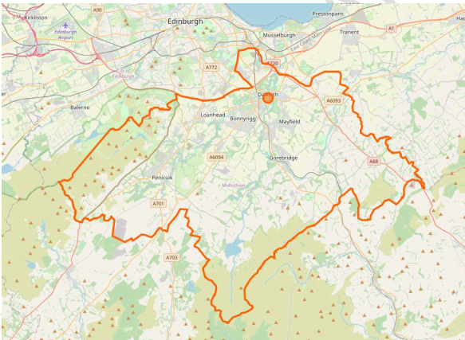
This study examined the different types of roads within the existing road network, with a view to better understanding their suitability for purpose within a local authority that has seen significant population growth and development in recent years.
Following on from the Roads Hierarchy Review, AECOM produced a draft Speed Policy document for review by Midlothian Council. This set out Midlothian Council’s objectives in relation to speed limits, as well as outlining the guidance used to determine the policy and methods which could be used for implementing the policy.
Figure 1 Roads Hierarchy Study Area
The purpose of this Briefing Note is to raise awareness of the proposed speed limit policy, and to outline how and when the public and interested stakeholders can feed into the process.

Speed Limit Policy Overview
The setting of national speed limits for different road types is the responsibility of the UK Government. The three national speed limits for cars, motorcycles and light vans are:
- The 30mph speed limit on restricted roads (in Scotland Class A, B or C or unclassified roads with street lighting).
- The speed limit of 60mph on single carriageway roads.
- The 70mph limit on dual carriageways and motorways.
These national limits are not, however, appropriate for all roads. The responsibility for determining local speed limits lies with the Roads Authorities, having regard to guidance issued by the Scottish Government together with relevant advice from the Department for Transport (DfT).
The setting of speed limits can be a sensitive issue for communities as residents and businesses can have conflicting views dependent upon their own experiences and how they primarily use the road space. As such, the Midlothian Speed Limit Policy seeks to provide some clarity as to what comprises an appropriate speed for various types of roads, and the environment in which the traverse through.
The Midlothian road network needs to support a local transport system that is safe for all road users and improves the quality of life in the communities that make up the council area, with the potential to encourage social and economic activity.
Scotland’s Road Safety Framework to 2030 states that Speed limits in a Safe System are based on aiding crash-avoidance and reducing the speed at which impacts occur. The Safe System aims to establish appropriate speed limits according to the feature of the road, the function it serves, and the physical tolerance of those who use it.
Table 1 below outlines the proposed criteria for determining the speed limit in towns, villages and small settlements. This is not intended to be a blanket policy, and decisions will be made on a case-by-case basis.
Table 1 Proposed Speed Limit Policy Criteria
Speed Limit | Implementation Criteria

Towns
20mph | - a clearly defined core, such as a central shopping area or community facility;  - several facilities generating active travel movements;  - notable development depth;  - almost continuous frontage;  - numerous junctions; and,  - significant pedestrian activity throughout the day.
30mph | - demonstrate the same criteria as above  - can be considered where motor vehicle movement is given higher priority than the place function of the street
40mph | - generally situated on the outskirts of urban areas with little frontage development and where there is limited residential development or the presence of vulnerable road users  - may be used as intermediate speed limits (“buffers”) on approach to built up areas where a lower speed limit may apply

Villages and Smaller Settlements
40mph | - there are more than 10 houses directly fronting the road (on one or both sides); and  - there is a minimum density of 3 houses every 100m; and  - there is a community facility such as a school, shop or village hall within the settlement.
30mph | - demonstrates the same criteria as for 40mph; and  - there are more than 15 houses directly fronting the road (on one or both sides).
20mph | - demonstrates the same criteria as for 30mph; and  - there are more than 20 houses directly fronting the road (on one or both sides); and  - there is street lighting no more than 38m apart; and  - there is a continuous footway along at least one side.

Rural Roads
60mph (single)  70mph (dual) | - speed limits on rural roads will be considered on a case-by-case basis, taking account of factors such as collision history and road character before adopting a lower speed limit  - rural roads with high speeds must have a 40mph ‘buffer’ or other visual marker to alert drivers to an upcoming settlement  - where appropriate, Midlothian Council will consider the implementation of ‘Quiet Routes’, where road users are encouraged to share the space, rather than priority being given to motor vehicles. Characteristics for these routes include:  - Daily traffic volumes of less than 800 vehicles per day (two-way);  - Carriageway no greater than 5.5 metres wide;  - Routes already used by pedestrians, cyclists and equestrians;  - Routes provide a link to existing infrastructure; and  - Has the support of the community, emergency services and elected members.

There will be locations where drivers’ speeds are too high for the prevailing local environment and further intervention is required to achieve good compliance with the existing or a lower speed limit.
Speed management measures include:
- raising awareness
  - education
  - promotion
- enforcement
  - regulatory signage
  - police enforcement
- engineering
  - Visual/audible alterations including road markings, rumble strips, gateway features and vehicle activated signage
  - Physical alterations to the road layout including road narrowing, ‘Give and Go’ chicanes, speed cushions/road humps and raised tables
  - Additional active travel infrastructure including cycle lanes, widened footways and pedestrian refuge islands

Consultation and Engagement
Public and stakeholder engagement forms a vital part of any policy development and, as such, Midlothian Council will open a consultation process on November 1st.

How you can help
Midlothian Council would like to receive feedback you may have in relation to the speed limit policy, with particular focus on the following elements:
- existing speed limits in your local area
- implementation of 20mph speed limits in towns, villages and smaller settlements
- speed limits on higher speeds roads and how these impact road safety and access to active travel
Comments can be submitted via the Placecheck Tool available at:

The tool allows comments to be added using an online map of the study area. Community Councils are also being contacted to promote the study and will be encouraged to access the Tool.

Timescales
A public and stakeholder consultation will run from November 1st until November 29th, 2022, allowing a four-week consultation period.
If you have any queries, please contact the AECOM project team at midlothianspeedpolicy@aecom.com

