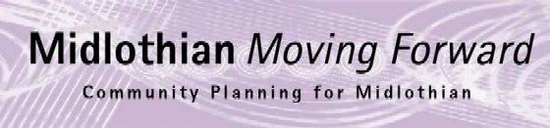
CPP Board Minutes
Thursday 7th December 10.00am via Microsoft Teams

Present: Annette Lang, Ann Stewart-Kmicha, Bryan Pottinger, Dave McCallum, Dona Milne, Emily Brown, Grace Vickers, Kevin Anderson, Lesley Kelly, Nick Clater, Nick Croft, Roddy Henry, James Robertson, Pauline Winchester, Kelly Parry, Jim Sherval, Joan Tranent, Sam Carlin, Michelle Strong, Gill Main

Apologies: Audrey Cumberford, Craig Sheerin, Fiona Robertson, Gary Clark, Hilary Sangster, John Dunn, Morag Barrow, Murray McEwan, Penelope Curtis

Minutes

Item | Minutes | Actions
- Minutes  - Matters Arising  - Bylaw Updates  - CPP regional meeting | Approval on Nov 23 minutes  a) A meeting has taken place on Bylaws further work is required to consider what other authorities use bylaws or policy changes for.  b) An email to community planning leads across the South East of Scotland including the Borders. Annette met with East Lothian who have confirmed they are happy to participate. The agenda will cover structures of community planning, good practice and identification of any cross boundary issues we can work on together.
- Action Log | Action log was reviewed and updated.
- CPWG Update & Asks | LK provided an update on the CPWG meeting. For more details please see the attached:  The CPWG had the following asks of the CPP Board:  - Community members are finding it difficult to keep on top of everything that is happening. How do senior leaders ensure everyone is aware of the multitude of initiatives?  - There is lots of good information on active travel and transport projects, could the Council produce an info graphic on projects going on?  - The CPWG wanted to highlight the need to continue to deliver and develop high quality youth work opportunities.  Annette drew the Board’s attention to the opportunity to contribute to the national CLD review. Annette also drew the Boards attention to the benchmarking report undertaken nationally on CLD. For more details please see the links below:  Independent Review of Community Learning and Development: terms of reference - gov.scot (www.gov.scot)  CLDSC Report on Local Authority Community Learning and Development Budget Allocation 2023/24 | CLD Standards Council for Scotland  Lesley outlined that in September 2023, the TSI Scotland Network undertook research with Chief Officers of TSIs to establish how involved the local third sector had been in the development of UKSPF, and to identify learning for both the third sector and the UK Government. Alongside a full research report, the Network has produced a summary document and two case studies from Clackmannanshire and Midlothian.  Overall, the research identified that across Scotland there had been limited engagement with the third sector over the Investment Plan and how UKSPF funding was distributed locally. I am delighted to say that Midlothian was one of the few areas which bucked this trend, and the Network included it as one of two case studies promoting good practice.  The research included a set of recommendations for the UK Government, with the key one being a request not to end the UKSPF without their being an alternative fund in place.  You can find the full set of research papers here: UK Shared Prosperity Fund (UKSPF) – TSI Experiences of Engagement (Nov 23) – TSI Scotland Network | KA to take the request of an info graphic to transport team and secure appropriate support
- Cost of Living Task Force Update | The Council audit report identifies the establishment of a cost of living task force was identified as a positive initiative that has improved services. The focus of the last cost of living task force group was employability. This was because employability is a key driver to reduce child poverty. The cost of living task force were impressed with the range and impact of employability services offered. CP Board members can access information on employability services from the link below as well as the No One Left Behind Operating Plan for Midlothian: NOLB Midlothian's Employability Strategy and Action Plan for Employability  There is also information available on the key services and trusted partners and their operating hours over Christmas. Please see below:  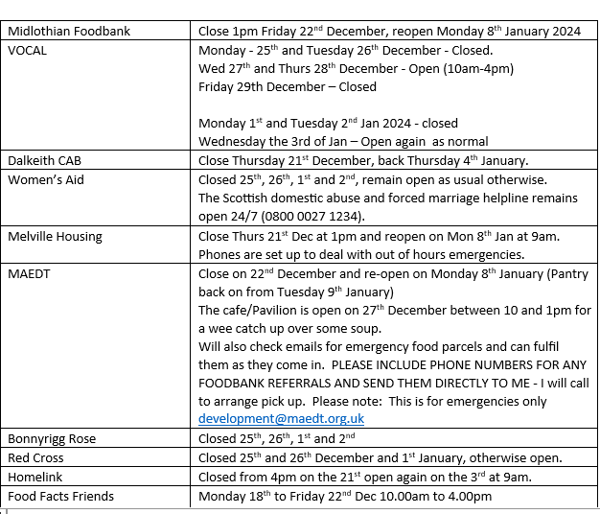  The CPP Board were also reminded of the additional support available through the cost of living task force including: Warm and well hubs (local people can ask for Alex at the warm and well hubs for free food if they do not wish to state they require free food), Wash & Dry clothes service and also the free food which is reheatable and delivered by the Red Cross to people’s homes (referral only)  Grace Vickers suggested that case studies from employability and also from Midlothian Young People awards could be used to promote positive stories of adults and young people.
- National Equally Safe Strategy | The National Equally Safe Strategy was launched 2017 but has been updated and relaunched December 2023. The vision of the strategy is “A strong and flourishing Scotland where all individuals are equally safe and respected, and where women and girls live free from all forms of violence, abuse and exploitation – and the attitudes that help perpetuate it”. Equally Safe recognises VAWG as a major public health issue and sets out a commitment to adopting a public health approach to tackling VAWG, which focuses on preventing VAWG before it occurs.
- Midlothian’s Equally Safe Draft Strategy & Board Discussion | Joan Tranent presented Midlothian’s draft Equally Safe Strategy 2023-2027. The document outlines what is VAWG and what we have achieved so far. The estimated female population of Midlothian is 49,000 and with 1 in 3 experiencing domestic abuse, it is a worrying statistic. The plan sets out the strategy for Midlothian with key actions to reduce violence against women and girls. Feedback and comments are welcomed and we would ask these are submitted by: 15th January 2024  Rebekah was thanked for her co-ordination work and pulling the strategy together along with the Improvement Service.  The following link may be of use to those working in this area: Respect Her Space – The City of Edinburgh Council | All feedback by 15.01.24
- Views of 772 young people – youth work | Please see presentation attached which outlines the responses of 772 young people in relation to what youth work opportunities they would like:  Grace Vickers suggested we need to identify and communicate a variety of positive stories on impact children and young people are having in their communities. Annette will contact Lynn Cochrane to progress this.  Public Health highlighted the results of the following research which supports the need for youth work and work experience: Youth Volunteering – Get Involved (nhslothian.scot)  Work Experience – NHS Lothian Careers | Keith to contact Annette in regards to focus groups with young people in relation to Sestran funds from the community bus fund – how to move towards a world class bus service. Will provide update at January meeting. Aiming to complete work by June/July 2024
- LHEES Presentation | Emily Brown presented the Local Heat & Energy Efficiency Strategy highlighting key policies, local authority progress, heat network zones, net zero solutions, funding, and investment. For more details please see the attached: | Cllr Pottinger to put Emily in touch with training academy at Hardengreen
- City Deal | Kevin Anderson provided an update on City Deal and took the partnership though the dashboard which had updated details. Leaders have met with their counterparts at the Dunard Centre to explore the outreach benefits for Midlothian.
- AOB | Lesley Kelly highlighted that Edinburgh Ukraine partnership scooped two awards at the 2023 Scottish Public Service Awards hosted at the Scottish Parliament on Wed 6 Dec – Commercial Partnerships and Voluntary Sector Partnerships. EVOC News - EVOC  Management information from Edinburgh College for Midlothian to students:  Midlothian Libraries won the SLIC Service Excellent Award which put communities at the heart of their service.  SLIC
 | Date of next meeting 25th January 2024

