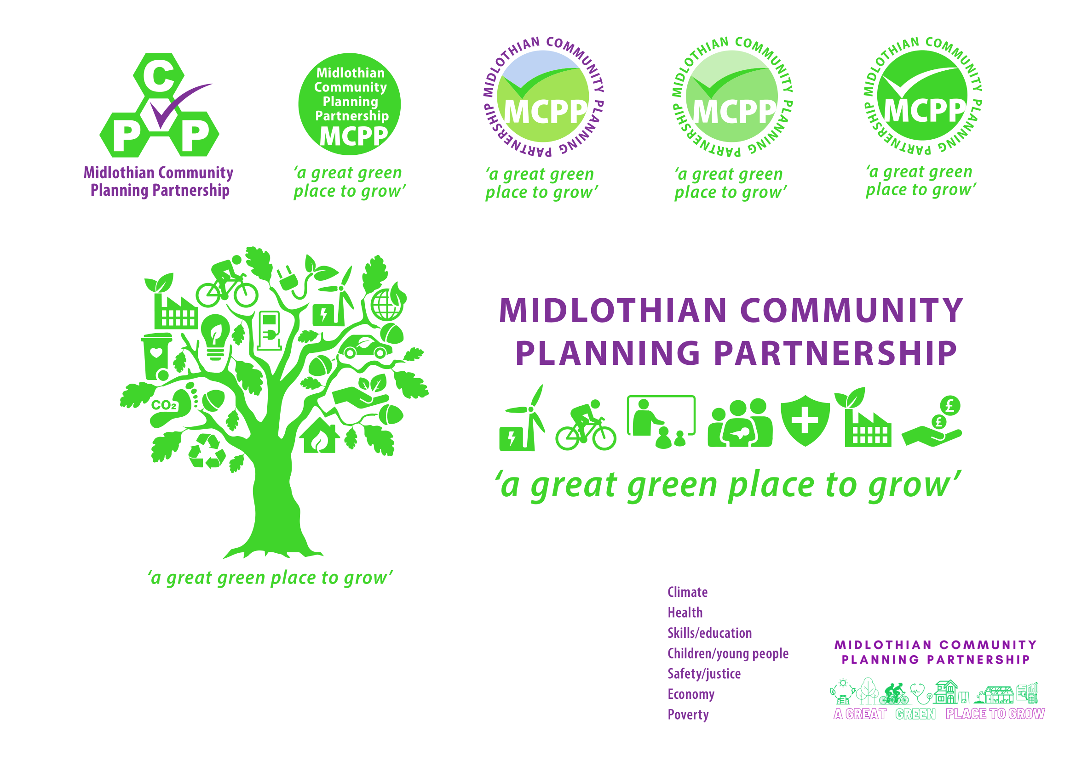
Community Planning Partnership Board Meeting
27th March 2025 at 10.00am via Microsoft Teams

Present – Annette Lang, Ann Stewart, Elliot Whitsonn, Fiona Kennedy, Fiona Robertson, Grace Vickers, Keith Fisken, Kevin Anderson, Lesley Kelly, Nick Clater, Rebecca Hilton, Rebecca Hooton, Rebekah Sullivan, Steve Oliver, Steven Young, Cllr Willie McEwan, Roddy Henry, Cllr Kelly Parry, Michelle Strong, Cllr Peter Smaill, George Archibald, Ann Stewart -Kmicha

Apologies – Julian Holbrook, Morag Barrow, Michael Jeffrey, Jim Sherval, Nora Ferda-McKay, Jamie Bell, Gill Main, Fiona Wright, Dona Milne, Dave McCallum, Audrey Cumberford, Claire Ross, Lynsey Davidson, Marc Pincome, Penelope Curtis, Sam Carlin

Agenda Item | Minutes | Action
Approval of minutes | The board approved previous meeting minutes
Action Log | Annette Lang (AL) provided a review of action log and updates; this will be attached with the minutes. | AL
CPWG update | Lesley Kelly advised of two asks from the group.  The Subgroup paper has been circulated and a couple of areas of work require a reporting and scrutiny line within the community planning group structure, first was resettlement steering group. Trauma informed practice group and equally safe steering group to be brought to working group.  It was pointed out that going forward we may require a criterion for work coming to community planning working group, rather than existing subgroups.  Grace Vickers (GV) suggested this could be built into self-evaluation plan. To give more clarity and declutter items being discussed in multiple places.  LK raised the other discussion point which was the use of AI and the increase in AI note takers being sent to meetings. There was concern with the use of this due to the ability of them sending a verbatim account of meeting to all attendees/invitees. Concerns around this are in terms of confidentiality, information can be uploaded to cloud for training purposes so potential data breaches. One of the difficulties is that new technology which is embedded in Microsoft which could result in people doing that unintentionally without appropriate training.  Planning group is asking for what the protocol should be at present.  GV advised that a decision was made at public protection community that AI cannot be in that space and welcome protocol across full CPP.  AL advised as it will take time for RS to get the protocol produced, on approval from the chair for the purposes of the minute that we will not be using AI notetaker in any of the community planning forums.  ASK asked to highlight TSI merger and will be known as Midlothian Community Action– the launch event will take place on 3rd April 2025.
Reflections from self-assessment and Action Plan | AL for those who didn’t attend the session, is happy to run bespoke session out with this meeting to provide more information.  AL provided an overview of findings of the sessions, 17 responses received to self-evaluation of community planning looking at key aspects of it. There are 29 local authorities participating out of 32. Positive aspects in terms of shared leadership and shared ownership. Also highlighting the role of elected members, the sharing of roles and responsibilities.  AL highlighted we scored well in connecting with communities and identifying needs of communities and helping local people have a voice in terms of community engagement.  There were 224 responses nationally, in terms of Midlothian, we scored within top 5 nationally except for 1 area which was in the top 10.  Draft improvement plan, two areas looked at were, consider how partners can improve the sharing of data to support work of the partnership, and we have 4 steps on what can be done to move this forward. The other was reviewing resource sharing arrangements within CPP again with 4 suggested actions.  We need to look the action plan and get feedback, agree timeframe and create working groups.  For those who attended session –  Can you reflect on experience of self-evaluation, was it positive and what do you think about areas of improvement?  LK commented she thought the improvement service did it well and got a lot out of the 40-minute session. As this was carried out across the whole of Scotland, they will have identified other authorities who are doing very well and would be interesting to look at mentoring or partnering with other community planning partnerships, who possibly are better on data sharing and a good source of support for AL and RS.  GV agreed, she liked the process they followed. They stated they would be writing up case studies on top 5 so we will be contributing to these. Would be good if we can learn from other areas also.  Rebecca Hooton (RH) wanted to express thanks to AL and RS for all the background work and acknowledgement of work involved. Other suggestions for board to consider, how do we structure our board meetings to ensure there is enough time for scrutiny for reporting. Plan agendas for meetings going forward.  Circulate the action plan received from Improvement Service with the minutes.

Citizens Panel Update | Main update listed below in action log.  RS has been working with procurement and legal to start the quick quote exercise. Confirming wording and terms and conditions. If anyone has any suggestions on companies who can be included in the procurement exercise this would be most welcome.
AOB | KP provided feedback on round table event discussion on National Insurance contribution increase which will affect community planning partners, third sector and wider businesses.  It was very helpful and positive proactive way to bring together commercial business, third sector and charities in talking about what the impact will be.  LK agreed that it was very positive to be in the room with private sector businesses. Only downside was there was a good listen from MP however no assurances about mitigation on national insurance contributions.  AL provided update on census information regarding the interactive maps. AL, RS and RH have met with health intelligence until within NHS Lothian to look at what the best way to extract information is without replicating tables/maps available. As an interim update RS will publish in the Midlothian profile by end of April to assist with use of service planning and funding applications.
Date of next meeting | 5th June 2025

