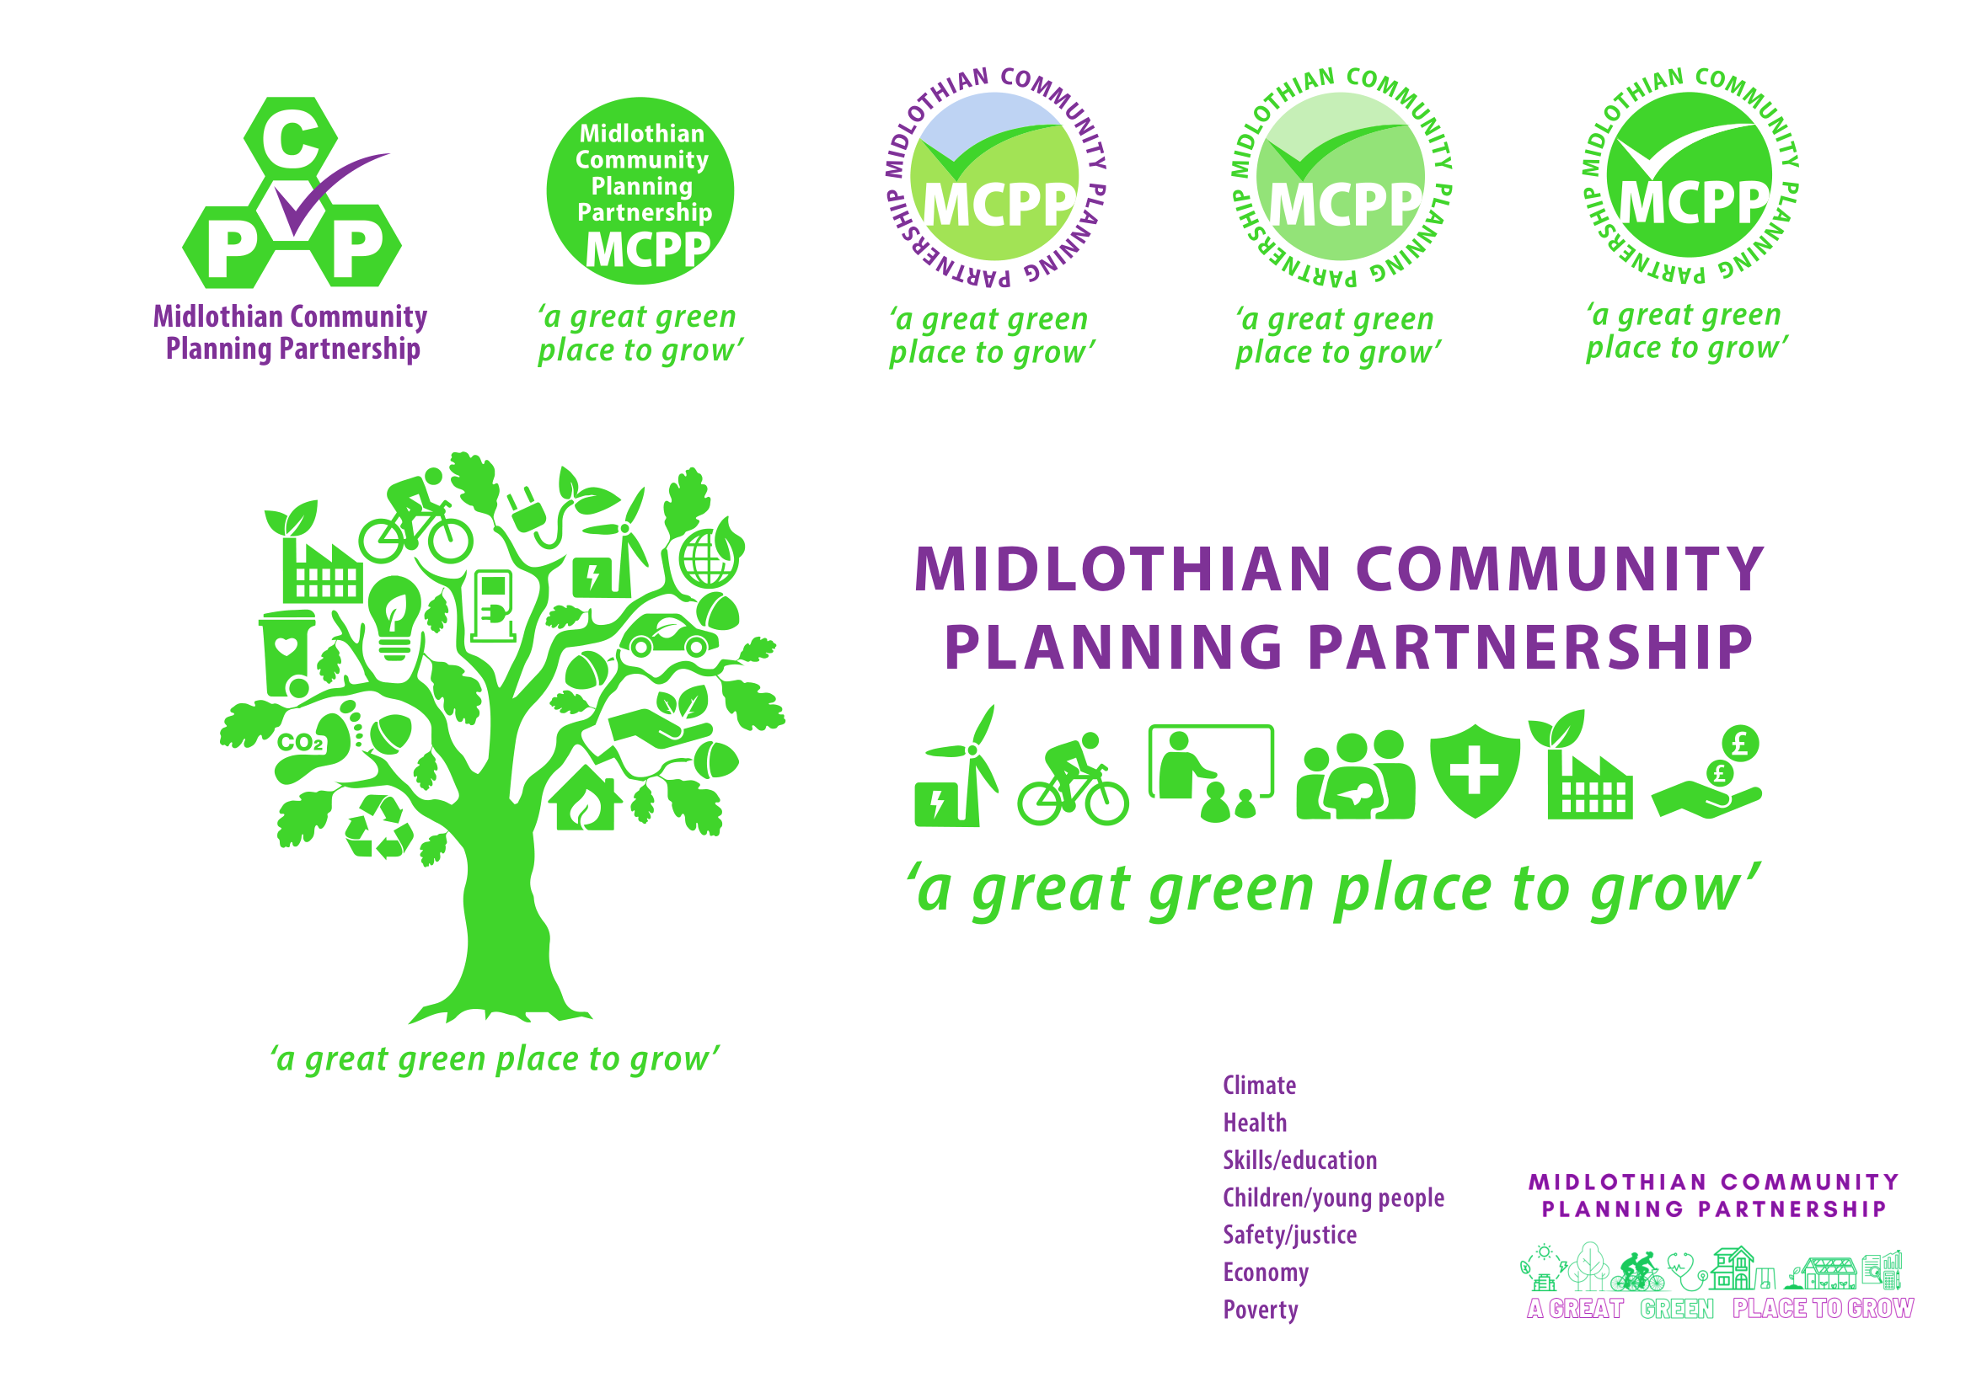
Community Planning Partnership Board Meeting
5th June 2025 at 10.00am via Microsoft Teams

Present – Cllr Kelly Parry, Grace Vickers, Elliot Whitsonn, Fiona Robertson, Kevin Anderson, Lesley Kelly, Nick Clater, Rebecca Hilton, Rebecca Hooton, Rebekah Sullivan, Steve Oliver, Cllr Willie McEwan, Michelle Strong, Cllr Peter Smaill, George Archibald, Ann Stewart -Kmicha, Julie Jessup, Nora Ferda-McKay, Jamie Bell, Fiona Wright, Claire Ross, Patricia Robertson, Dee Kieran, Annie Watt, Karen McGowan, Wendy Campbell, Chris Miller, Annette Lang.

Apologies – Kirsty McArthur-Kerr, Andrea McCann, Audrey Cumberford, Fiona Kennedy, Jim Sherval, Joan Muir, Keith Fisken, Lynsey Davidson, Morag Barrow, Murray McEwan, Pauline Winchester, Roddy Henry, Steven Young

Agenda Item | Minutes | Action
Approval of minutes | The board approved previous meeting minutes  Matters Arising  Improvement Action Plan:
Action Log | Annette Lang (AL) provided a review of action log and updates; this will be attached with the minutes. | AL
CPWG update | Lesley Kelly presented the discussion from the CPWG highlighting the complexities on reporting on a four-year plan. Areas for consideration included long-term planning, changes, and emerging challenges. They considered whether targets should remain fixed, be adjusted periodically, or replaced with a different approach, and agreed to revisit the issue over time.
H2 Reporting | Thematic leads presented their H2 action updates, highlighting challenges and successes. Potential challenge questions were posed to the Board to help with challenge and scrutiny.
H2 Reporting Q&A | Lesley to ensure a tracker note on external funding is included at each subgroup meeting due to ongoing changes.  Q: A question was asked to Claire on the annual report and the 'Healthier' theme?  A: She noted it relates to the current discussion and raised concerns about clarity. Claire was requested to give more information on community appointment days.  Q: Dee was asked why only 3 out of the 4 subgroups mentioned in the GIRFEC update.  A: Dee noted the 4th group was paused in Autumn 2024 due to the MLC Transformation Programme. Joint commissioning and info sharing are being reviewed to avoid overlap. A pan-Lothian info-sharing protocol is now in place.  Q: Wendy was asked to expand on the information about transport?  A: She referenced Action 8.2, noting work in Loanhead and Dalkeith (St. Andrews Street).  Q: Lesley Kelly asked what was being done on the rising private rents?  A: Kevin responded that the LIFT scheme is still active, rent control is part of the housing bill with 6,300 amendments, and tenancy grants are available. Lesley suggested promoting the LIFT scheme.  Q: Rebecca Hilton asked for an update on the Stage 2 Housing Bill?  A: Kevin confirmed it will go to council in October and be part of the 2031 Local Housing Strategy. A review of the allocation policy is unlikely soon and will be added to the action log.  Cllr Smaill highlighted the impact of the two-child cap, noting only 14% of families have three children, but those affected face significant stress. | LK
Draft Annual Report Presentation | A copy of the annual report will be presented to the June council meeting, with circulation to follow and any urgent changes incorporated afterward. The report uses the same format as last year, and the executive summary will be adapted into an easy-read version for the public.  Annette expressed appreciation to partners and volunteers for their contributions.

AOB | The Improvement Service are conducting and evaluation. The link has been shared with partners.  Volunteering - A survey was distributed to MLC volunteers and third sector partners, receiving 66 responses. The feedback highlighted the value of their experiences, and it is intended to reflect this back to volunteers. A report summarising the findings will be circulated by Lesley.  Sheriff Hall Roundabout - Ann Stewart-Kmicha noted that a question regarding the Sheriff Hall Roundabout was scheduled in Parliament that afternoon. Kevin is monitoring the Scottish Government’s responses. Grace referenced the Joint Committee and a report from Transport Scotland, which was being debated and broadcast on Parliament TV.
Date of next meeting | 11th September 2025

